# http://austinea.org/image/austinLogo.jpg

*Service Catalog for Strategic Success*

Enterprise Architecture

at the

City of Austin

Table of Contents

1

Introduction 3

Cataloging Business Process Workflows 5

Figure 1- Activity Diagram Example 6

Create Interface Documents Describing System Interactions. 8

Figure 2- Sequence Diagram Example 9

Figure 3 - Sequence Diagram Interface Table Example 10

Capability Mapping 11

Figure 4- Capability Area Architecture Diagram 11

Strategic Planning 13

Figure 5 – Austin Public Health Capability Model 13

Figure 6- Sample Strategic Plan for Department 13

Create Interaction Overviews 15

Figure 7- Convention Center Interaction Overview 15

Consulting Services / Analyzing Operations 17

Figure 8 - Sample Data Usage Analysis 17

Figure 9 - Gartner Magic Quadrant for file sharing 17

Create Data Models 18

Figure 10 - Convention Center Logical Data Model 18

Create System Diagrams 20

Figure 11- APD Cry Wolf System Context Diagram 20

Create an EA Website 21

Figure 12 - Animal Services EA Website 21

Assist with Formal Project Technical Requirements 22

Provide Training for Reading Enterprise Architecture Artifacts 23

# Introduction

The Enterprise Architecture (EA) team at the City of Austin is comprised of a group of highly skilled IT professionals who would like to help Departments with their technology needs. Pursuant to that desire, here’s a list of potential activities Enterprise Architects provide to Departments. Clearly we need Subject Matter Experts (SME’s) from a Department team to work with us to create anything, but assuming those resources are available, here is a general list of the kinds of value add services the EA team can provide. Each bullet has a chapter in this catalogue with pictures of the common deliverables, and lists the necessary resources and timeframes to create each.

* Cataloging Business Process Workflows:

Create a catalogue of all your Business process workflows. Need to create a standard operating procedure manual for your department? Enterprise Architecture can help.

* Create Interface Documents Describing System Interactions:

Perform an analysis of the Programs and systems your group uses, and produce interface documents and data schema’s for the layout of your critical data and how it’s currently used.

* Capability Mapping:

Conduct an analysis of your organization and provide a summary of the services (Capabilities) of which an organization provides (this includes the creation of vision and mission statements).

* Strategic Planning:

Work with your Department to create strategic plans (roadmaps) for your organization for 6 months, 1 year, 5 year or even 10 years in the future. This includes identifying goals and aligning to the City Council Outcomes (Economic, Mobility, Health, Safety, Cultural, Working Government).

* Create Interaction Overviews

Perform analysis and create diagrams to map out the interactions between multiple processes, providing links to critical data needed for the processes to function as designed.

* Consulting Services / Analyzing Operations:

Analyzing current state of your operations to determine potential causes of issues between processes. This includes analysis of Log files, creation of timing charts comparing processes along timelines, vendor upgrade suggestions, interviewing resources, and making suggestions for potential improvements of your IT infrastructure. General consulting Services to analyze and suggest ways in which your organization can make better use of Business Intelligence, Mobile Apps, or even provide insight into existing City of Austin Resources of which your organization might make use. Let us be the technical resource for your department when working with a vendor. We can help translate the techno-babble into modern day language for you to understand exactly what a vendor is and isn’t saying.

* Create Data models:

Analyze the critical data relationships which describe a current or future state of a department’s software and/or processes.

* Create System (context) diagrams:

Analyze a Departments Technical eco-system to create drawings of the physical layout of a department’s computer hardware, databases, and software.

* Create an EA Website

Often technical analysis is lost the moment a project is completed. Enterprise Architecture is about preserving all analysis so it may be reused in the future. Pursuant to that goal, the EA team will create a website listing all analysis related to a Department; provides all of a department’s EA artifacts at their fingertips, and providing a way to refer internal and external customers and coworkers to anything EA they’d like to share.

* Assist with Formal Project technical Requirements:

Assist The Project Management Office with preparation of detailed requirements on Request for Information (RFI) and Request for Proposal (RFP).

* Provide Training for how to read Enterprise Architecture Artifacts.
* Provide Certification Training to become an Enterprise Architect.

## Cataloging Business Process Workflows

Often times one wishes they had flowcharts to describe processes used in their organization. The Enterprise Architecture team create diagrams called “**Activity Diagrams**” that merge simple flowcharts with designations of the people doing the processes, and the data required to do those processes. The EA team will work with your department to analyze the roles and data required to do a process, and construct diagrams to be used in standard operating procedure manuals, or simply to diagram step by step workflows. These diagrams tend to not include information specific to systems, but mainly focus on human interactions.

Each Workflow, also includes a scope statement. This is a step by step description of the process, written in first person.

Example Scope Statement:

**Scope:**The CTM Liaison uses the Record Control Schedule to determine the filing specifics for a specific document type. The CTM Liaison uses InfoLinx to request boxes and Labels. The City Clerk's office sees the request for boxes and labels and contacts the document storage company to have the labels and boxes sent directly to the CTM Liaison. The Liaison organizes records being stored within boxes according to the following rules:

* Limit box contents to one record series per box and a single year.
* Records with a CYE (calendar year end) trigger must be boxed by calendar year.
* Records with a FYE (fiscal year end) trigger must be boxed by fiscal year.
* Records with event-based triggers AC (after completion), US (until superseded), or LA (life of the asset) that span multiple years (such as contracts or project files) must be boxed according to the closing date.

Boxes with PM (permanent) retention may include multiple years.

The CTM Liaison then prints the order information and affixes it to the packed box(es). The CTM Liaison makes entries in an inventory log listing box contents, Storage Company tracking information, date sent and other important tracking information. The information is also entered into the InfoLinx system in accordance to the city InfoLinx guide. The CTM Liaison sends the CTM records administrator notification the boxes are prepared. The Administrator verifies all information and uses InfoLinx to send a pickup request. The City Clerk receives the pickup request via InfoLinx and contacts the Document Storage Company, who in turn provides pickup information. The City Clerk communicates the pickup information and forwards the information to the CTM Liaison. The CTM liaison either meets the Storage Company at the arranged time, or arranges for someone to drop off the boxes as scheduled.

The scope statement above goes with diagram shown below ( Figure 1- Activity Diagram Example ). The following diagram shows the process CTM uses to “Send Records Offsite”. There are four people involved in the process; a CTM records Liaison, a CTM Records Management Administrator, the document Storage Company, and the City Clerk. Each role gets their own column in the diagram. Blue circles indicate steps in the process, green boxes indicate the data used with each of the process steps. The diagram shows the flow of steps in the process, with the data needed to do each step.

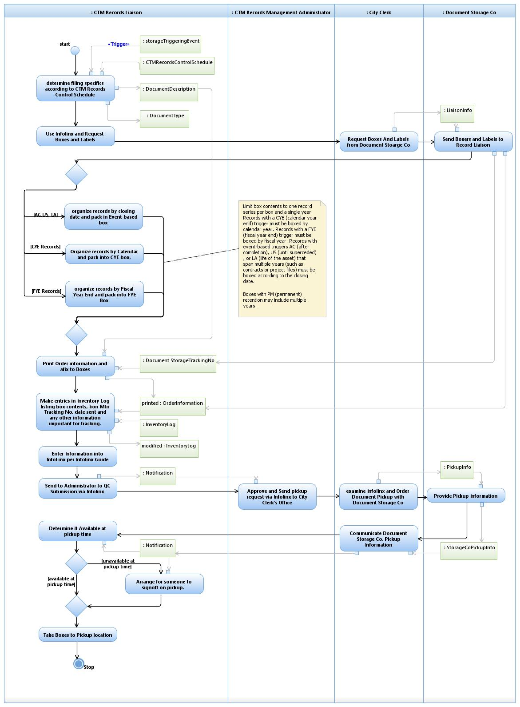

Figure - Activity Diagram Example

Normally, this kind of diagram takes between 4 and 6 hours to create, and will require three hours of a subject matter expert’s time split across two in person meetings. In general, meetings are two hours long each. Obviously, if the SME isn’t familiar with the process, the process is highly complex or a new process is being conceived, the analysis part of the diagramming may take longer.

The diagram is delivered in WORD, as well as in HTML (if the Department has a website on which they’d like it displayed.) Optionally, the Enterprise Architecture team can create a website for artifacts, if this is desired. (To see more information about website creation, see the Website Creation Section.)

## Create Interface Documents Describing System Interactions.

Classically, organizations have a number of programs to which they are dependent. Often these programs are provided by vendors, or other organizations within the city, and have been in place for many years. Sometimes the software being used has been developed within the city. When considering migrating off of these programs to newer, more modern solutions, or perhaps modifying these programs to have improved functionality, there is a necessity to identify potential risks. Upgrades or migrations take technical planning to reframe a department’s technical eco-system. Departments have goals of integrating mobility applications, and/or housing their data in a shared cloud storage. As with a house, one would never consider spending huge sums of money without a blueprint. The Enterprise Architecture team can analyze the systems your group uses and working with your SME’s come up with diagrams that:

1. Describe the current way the software in your technical eco-system interacts
2. Describe the future state of how software should interact
3. Describe the data that’s critical to your being able do business
4. Describe the business rules that predicate specific system mechanisms

The Enterprise Architecture team creates diagrams called “Sequence Diagrams”, which break a process down into a series of “messages” between entities. These diagrams include the data needed for the communications, and detailed descriptions of each message which accompany the diagram. Each system or person involved in the process is assigned a column in the diagram, and arrows indicate which system initiates and which provisions the service required for the interaction.

Each process mapped includes a scope statement. This is a step by step description of the process written in first person.

Example Scope statement:

**Scope:**The Sales Manager uses the system to check the schedule to determine if there are conflicts (appropriate time to show space, availability of staff, etc.) The Sales Manager determines who should attend the site visit (catering , IT, event coordinators, security, etc.) and invite them to attend and then sends an email to all appropriate site staff to ensure the building is active (lights on, water fountains on, etc.). [Note: Some vendors do not want others to be able to see the convention center while they are renting (private meetings, secret info presented, etc.)]

The scope statement above goes with diagram shown below (Figure 2- Sequence Diagram ). The following diagram shows the process the Convention Center uses to “Schedule a Site Visit”. There are four entities involved in the process; an Event Representative, a Sales Manager, a Site Inspection Group, and a system dubbed “Establish Event Booking”. In this example the Convention Center wanted to map a future state, in which a new system (to be located and purchased in the future) would interact with their employees. Each role gets their own column in the diagram, as well as the future system. Each arrow indicates a specific transfer of information from the role in which the arrow starts to the role in which the arrow ends. The role touched by the arrowhead is the entity that provisions the requested information. Additionally, the arrows have text indicating the process the provisioning role will provide, as well as the data necessary for the

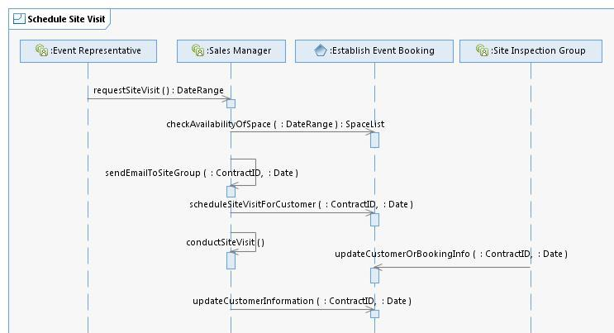

Figure 2- Sequence Diagram Example

Each Diagram is also accompanied by table that describes in great detail what each step (arrow) in the diagram implies. The associated table for this “sequence” diagram above follows ( Figure 3 - Sequence Diagram Interface Table ).

|  |  |  |  |  |  |  |  |  |  |  |  |  |  |  |  |  |
| --- | --- | --- | --- | --- | --- | --- | --- | --- | --- | --- | --- | --- | --- | --- | --- | --- |
| | **Type/Interface** | **Description** | | --- | --- | | Sales Manager/ requestSiteVisit | The Event Representative contacts the Sales Manager and requests a site visit. | | Establish Event Booking/ checkAvailabilityOfSpace | Once the customer meeting requirements are received, the Sales Manager uses the system to pull up an Event Diary which displays a grid indicating who is in what room, when, group status (current system color codes - contracted groups are displayed in one color, definite groups are in another - the system allows for the displayed colors to be configured), and what's currently available. The grid allows the Sales Manager to drill down to see other options offered to other potential groups. When a customer negotiates for business, they may provide several dates and space option(s) and each option is specified in the Event Diary. The Sales Manager uses the system to change the reserve space options and the system indicates different offerings and available space. The Grid also allows the Sales Manager to schedule site visits during times in which there is little or no event activity, as deemed appropriate by the Sales Manager. | | Sales Manager/ sendEmailToSiteGroup | The Sales Manager uses an Outlook Address Book group to send all the members of the Site Inspection Group an Email indicating the date a site visit will occur, indicating specifics desired by the Event Representative. | | FS073 Establish Event Booking/ scheduleSiteVisitForCustomer | The Sales Manager uses the system to annotate a site visit has been scheduled on a specific Customer Account. If the site visit is in relationship to a specific booking, the site visit is added/logged to the specific booking (Contract ID). If the site visit is occurring in the future, then an activity (trace) is scheduled to remind staff of the site visit. | | Sales Manager/ conductSiteVisit | The Sales Manager and the Site Inspection Group meet with the Event Representative to tour the facility, during which the Event Representative may provide additional booking information. | | FS074 Establish Event Booking/ updateCustomerOrBookingInfo | A member of the Site Inspection Group goes to the Customer Account or a specific Booking (Contract ID) and provides additional information related to the event or the customer. The system automatically sends email notifying the Sales Manager and/or the Sales Director for the booking/Customer, as well as automatically logging the activity. This notification is configurable by activity. The inspection Group cannot make changes to the booking information, or space planning. Only Sales Managers and Directors can affect these kinds of critical changes. | | FS075 Establish Event Booking/ updateCustomerInformation | The Sales Manager takes all the information garnered from the site visit with the Event Representative and adds them to the Customer Account and/or the Specific Booking comments (Contract ID). The booking is updated with any salient information (estimated attendance records, space needed, profile, competitors, comments, etc.). |   Figure - Sequence Diagram Interface Table Example |

Normally, this kind of diagram takes between 4 and 6 hours to create, and will require three hours of a subject matter expert’s time split across two in person meetings. In general, meetings are each two hours long. Obviously, if the SME isn’t familiar with the process, the process is highly complex, or a new process is being conceived, the analysis part of the diagramming may take longer.

The diagram is delivered in WORD, as well as in HTML (if the Department has a website on which they’d like it displayed.) Optionally, the Enterprise Architecture team can create a website for artifacts, if this is desired. (To see more information about website creation, see the Website Creation Section).

Often, these kind of diagrams are included as part of an Request for Proposal (RFP) or a Request for Information (RFI) to provide vendors with a schematic for how their system will interact with other systems in the department’s technology suite.

## Capability Mapping

When beginning to consider discussions about your organization with other leaders, knowing the makeup of your organization and being able to show diagrams which depict what a group or department supports can be critical. The Enterprise Architecture team can help lead the discussion to discern a department’s summary of services (capabilities), a mission and even a vision statement.

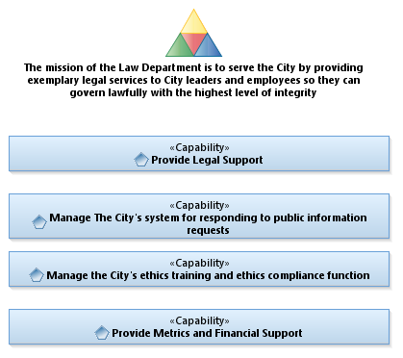

Figure - Capability Area Architecture Diagram

Each Diagram has an accompanying chart to describe in detail each Capability. For the above example (from the Law Department), the descriptions are as follows.

|  |  |
| --- | --- |
| Provide Legal Support | Act on behalf of the city to conduct "external" proceedings, including lawsuits, administrative proceedings, state agency proceedings (both regulatory and adversarial), and legislative matters. As well as "internal" proceedings including civil service appeals, non-consent tow license hearings, purchasing department protests, Board of Adjustment (BOA) appeals, etc. Prosecute Municipal Court cases related to all traffic citations and city code citations filed. Provide legal advice for officials, employees, and others acting on behalf of the city (e.g., members of some boards and commissions).Prepare contracts for various city entities. This includes all facets of contract development (negotiating, drafting, revising, reviewing, etc.). Prepare documents for city council action like ordinances, resolutions, election documents, etc. Deliver training to City personnel on legal compliance and policy adherence. This includes education and compliance training on existing laws and new legal developments and education on existing and new city policies. Prepare administrative bulletins, administrative rules, policy documents, internal memoranda, etc. |
| Manage The City's system for responding to public information requests | Provide administration of the Public Information request (PIR) system. This includes management of policies and procedures for response to public information requests. |
| Manage the City's ethics training and ethics compliance function | Manage City Ethics training, including consultation with city personnel on compliance issues, and with management on revisions to city ethics policy. |
| Provide Metrics and Financial Support | Provide financial management, human resource management, front desk management, Continuing Legal Education (CLE) program administration, office and legal research management, etc. in support of the law services for the city. |

Normally, this kind of diagram takes between 4 and 6 hours to create, and will require three hours of a subject matter expert’s time split across two in person meetings. In general, meetings are each two hours long. Obviously, if the SME isn’t familiar with the process, the process is highly complex, or a new process is being conceived, the analysis part of the diagramming may take longer.

The diagram is delivered in WORD, as well as in HTML (if the Department has a website on which they’d like it displayed.) Optionally, the Enterprise Architecture team can create a website for artifacts, if this is desired. (To see more information about website creation, see the Website Creation Section.)

## Strategic Planning

One of the great byproducts of a department creating a Capability Area Architecture (See the section on Capability Mapping for more information) is the realization of goals the department has.

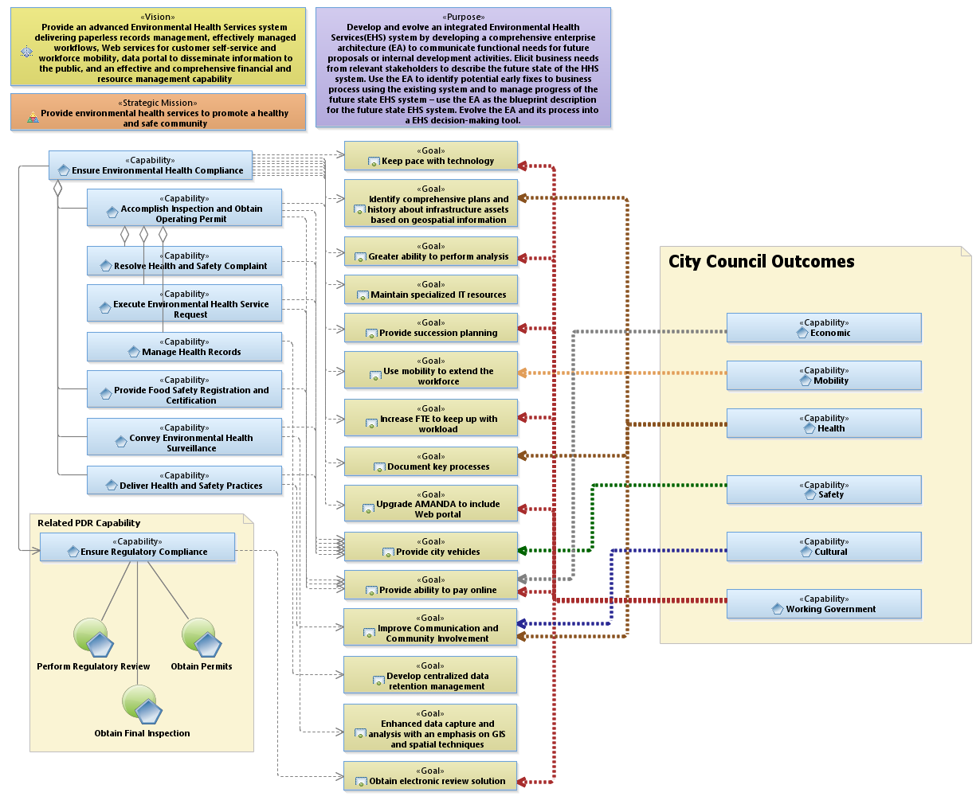

Figure – Austin Public Health Capability Model

The gold boxes indicate goals, with dashed lines back to the Services (capabilities) that would benefit from the goal. Goals with many dashed lines indicate the tasks which would have the most impact. The Enterprise Architecture team can help a department define their goals, and help strategize which contribute not only to their Capabilities, but also which align with the City Council imperatives. Through this exercise, the Department can sequence the goals they wish into a timeline, resulting in a strategic plan. In the public health example above, it appears the goals: “Providing City Vehicles”, and “Providing Ability to Pay Online” would benefit the most services, and are aligned with the City Outcomes. This implies these goals might be given priority as projects to initially attack.

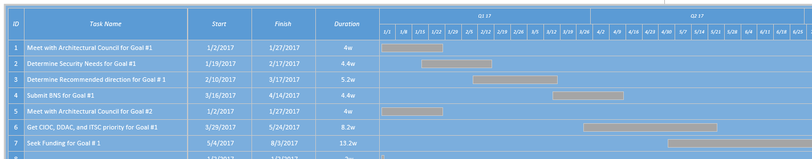

Figure - Sample Strategic Plan for Department

Normally, this kind of diagram takes between 8 and 12 hours to create, and will require six hours of a subject matter expert’s time split across three in person meetings. In general, meetings are each two hours long. Obviously, if the SME isn’t familiar with the goals they desire for the Department, the analysis part of the diagramming may take longer.

The diagram is delivered in WORD, as well as in HTML, and accompanied by a Microsoft Project plan timeline to which the Department can track their progress.

## Create Interaction Overviews

Because a department’s technical eco-system can be highly complex, it can be effective and useful to track the data flow and interactions of processes within an environment. Interaction overviews are a kind of flowchart which is augmented with information about the data produced (and used) by a process and is used to check the data integrity of a set of processes within a system. Often a department will want to consider replacing an existing system, and Interaction Overviews ensure the analyst can account for the “where from” and “where to” data elements of the system.

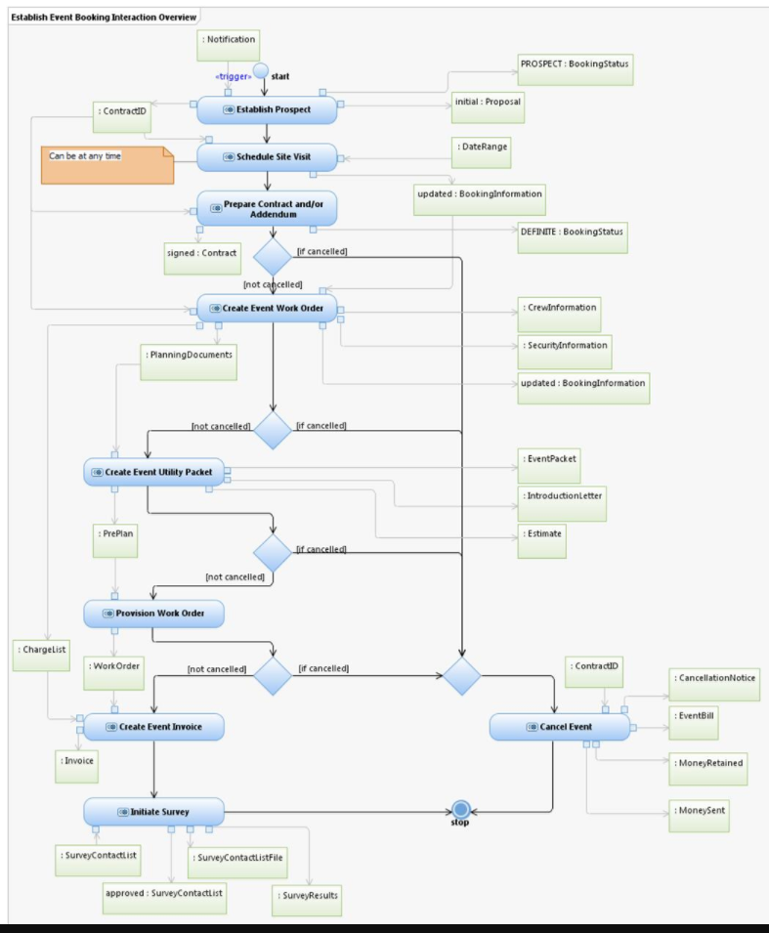

Figure - Convention Center Interaction Overview

Figure 7- Convention Center Interaction Overview, shows how the various processes within the Event booking process at the Convention Center interact. Each blue Bubble indicates a process, each green rectangle indicates a critical piece of data. Data is attached to a process by a little arrow, indicating if the data came from a process or is being fed to a process (or both)! This diagram doesn’t show ALL data, but only the mission critical data.

Normally, this kind of diagram takes between 4 and 6 hours to create, and will require many hours of a subject matter expert’s time split across many in person meetings. This is due to Interaction Overviews requiring analysis of each of the *processes* included, and therefore can be a lengthy process to create. If, however, the documentation about each of the subordinate processes is already completed, then it only takes between 4 and 6 hours to create (with no SME involvement.)

The diagram is delivered in WORD, as well as in HTML (if the Department has a website on which they’d like it displayed.) Optionally, the Enterprise Architecture team can create a website for artifacts, if this is desired. (To see more information about website creation, see the Website Creation Section.)

## Consulting Services / Analyzing Operations

Because Enterprise Architects are senior IT people, in general, they have much experience in the realm of understanding the underpinnings of technical eco-systems. Most have worked as programmers, Business Analysts, System Engineers, Database Administrators, etc., and most have a keen understanding of technology. With this knowledge, Enterprise Architects can analyze and provide valuable insight into the challenges of daily IT issues. Have a Process that has suddenly slowed down? Unsure how to size the disk needs for a new project you are spec’ing? Unable to determine a workflow for running a process in your department? Enterprise Architects can assist with the research necessary to help you make the management decisions required to finding what needs improvement. Sometimes you just need someone at the table that has a good understanding of your goals, and can act as your technology translator. Let Enterprise Architecture help your department figure out the problem or the next steps! Enterprise Architects often provide consulting services to analyze and suggest ways in which your organization can make better use of Business Intelligence, Mobile Apps, or even provide insight into existing City of Austin Resources of which your organization might make use.

These kind of engagements are unique in their scope and nature, so providing an estimate for a timeframe for completion, or the customer engagement required, is done on a project by project basis.

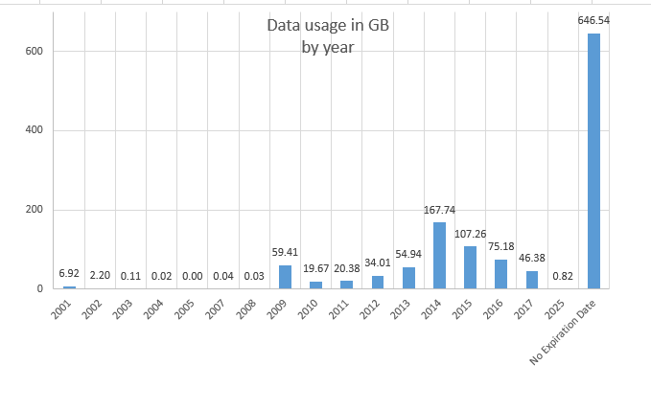

Figure - Sample Data Usage Analysis

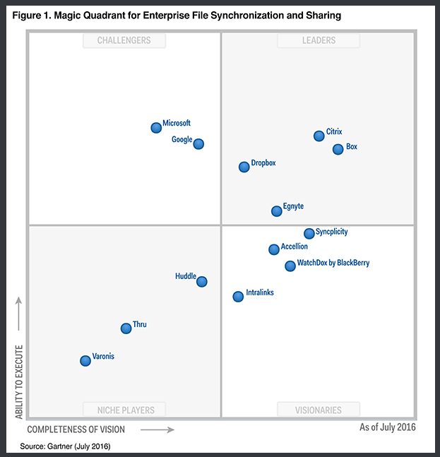

Figure - Gartner Magic Quadrant for file sharing

## Create Data Models

Throughout the city are hundreds of software programs, Databases, and Enterprise Service Buses (ESB’s) which constantly exchange data. Many happen in the background, initially set up at installation, whose content are completely a mystery. No historical repository exists today that catalogues these interfaces. Additionally, when integrating a new software solution, data imports and extracts are critical to getting historical data into the new system, or for coupling the solution to existing systems, not to mention supplying data to reporting warehouses. The Enterprise Architecture team can analyze a department’s current systems, or their current critical data, and provide diagrams which show relationships between your systems of record and data objects they use. Data diagrams are created as logical data models, allowing database administrators and vendors to understand the critical relationships, but not be tied to specific physical implementation methods. If you are considering implementing a new system, or replacing an existing system, getting a data model of your information is critical to communicating technical requirements, and to understanding system needs.

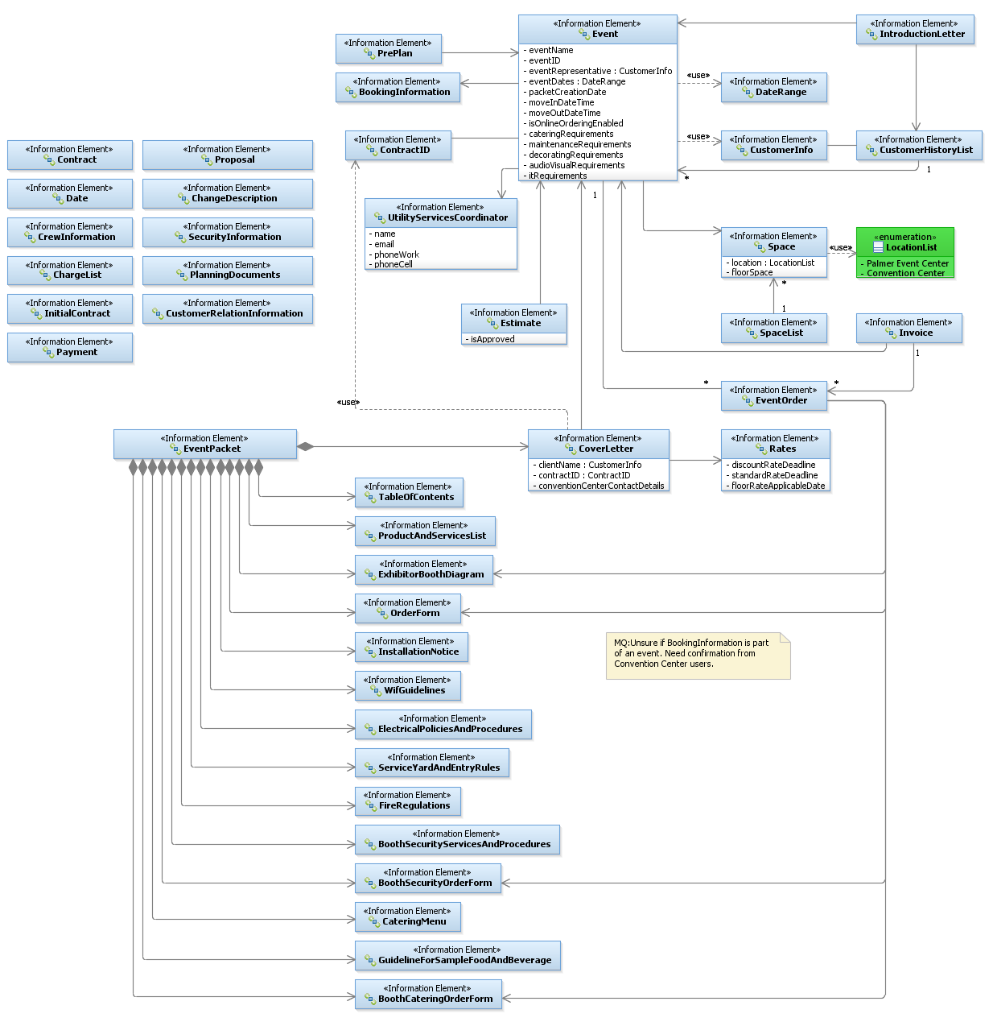

Figure - Convention Center Logical Data Model

Normally, this kind of diagram takes between 8 and 12 hours to create, and will require six hours of a subject matter expert’s time split across three in person meetings. In general, meetings are each two hours long. Obviously, if the SME isn’t familiar with the systems, or research has to be done with application owners, the analysis part of the diagramming may take longer.

The diagram is delivered in WORD, as well as in HTML (if the Department has a website on which they’d like it displayed.) Optionally, the Enterprise Architecture team can create a website for artifacts, if this is desired. To see more information about website creation, see the Website Creation Section.

Often, these kind of diagrams are included as part of a Request for Proposal (RFP) or a Request for Information (RFI) to provide vendors with a schematic for how critical data required for a department’s processes will interact with other systems in the department’s technology suite.

## Create System Diagrams

For every software product there is a set of hardware, software and data that exists to support its functionality. When considering risks and benefits of replacing a system or a set of systems, knowing all the software and hardware elements effected by the change is critical to minimizing cost and putting together a realistic plan. The Enterprise architecture team uses a graphic chart called a System Context diagram to provide a top down view of the composite elements comprising the product.

In the picture below, the green “X” icons () indicate systems which are actually Virtual machines, provisioned by a virtual memory farm designated by the double green X ().

Anytime a diamond with an arrow exists (), it indicates the thing with the diamond side contains the thing to which the arrow points.

Dashed arrows indicate a dependency; the element at the beginning of the dashed arrow depends on the item to which it points ().

The blue cylinders (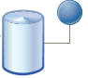) indicate a data source. A green X with a little DVD attached ( ) indicates software.

The green X with a little computer box (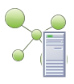) indicates an actual computer system in a casing with it’s own motherboard.

In Figure 11- APD Cry Wolf System Context Diagram), we see the layout of the APD Crywolf Software from 5 years ago. According to the diagram, “Internal Users” have a VM instance, that has a copy of the APD Cry wolf software, which depends on the CryWolfNet data, that resides on the VM machine APDSQL05, which has Microsoft SQL server installed, and holds that CryWolfNet data.

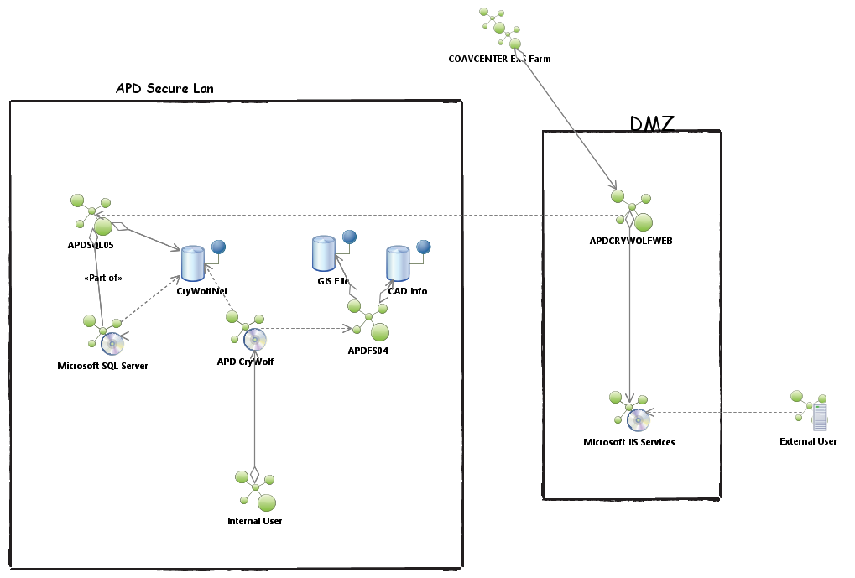

Figure - APD Cry Wolf System Context Diagram

## Create an EA Website

Often customers will have concerns their Enterprise Architecture work will only be accessible via the Enterprise Architecture team. As a byproduct of any Enterprise Architecture work with a department, the Enterprise architecture team will create and maintain a website of all documents, drawings and artifacts related to the information gathered during our engagement with a department. The website can be viewable to internal customers, external citizens, or even password protected and limited to a specific list of employees. In general, most departments, for transparency sake, prefer the website to be visible to citizens and employee’s alike.

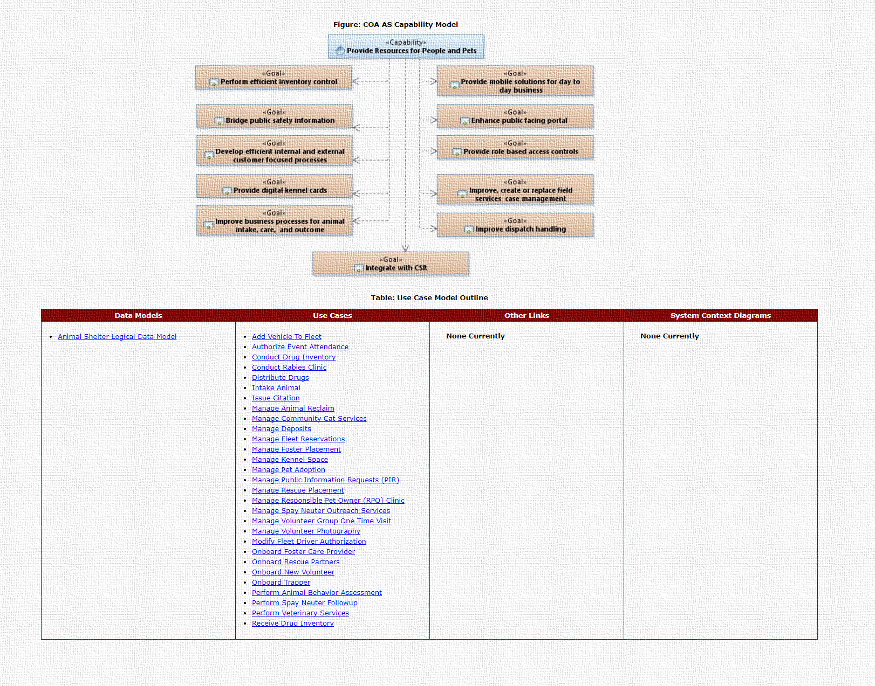

Figure - Animal Services EA Website

Figure 12 - Animal Services EA Website, shows the website established for the Animal Services team, found at (<https://cityofaustin.github.io/austinea/arch/as/report/>) .

The website is maintained within the City’s infrastructure, within a [GIT](https://en.wikipedia.org/wiki/Git) repository. This repository is backed up on a regular basis, and secure from viruses and hacking attempts.

It takes between one to two hours to code a webpage for each page of the website constructed. Typically there is one Webpage per Process/Artifact as well as a master page, like shown in Figure 12 - Animal Services EA Website providing the links to all other pages.

## Assist with Formal Project Technical Requirements

Often a department will have a desire to replace software solutions or implement new software solutions, but have no idea how to start. Many have no technical resources at their disposal, and need assistance with getting the technical details gathered in preparation for consideration by the various governing boards. The city offers many outlets for this discussion. Enterprise Architecture can be engaged to work with your department to do any of the following (as discussed in their respective sections of this document):

* Cataloging Business Process Workflows
* Create Interface Documents Describing System Interactions
* Capability Mapping
* Strategic Planning
* Consulting Services / Analyzing Operations
* Create Data models
* Create System (context) diagrams

Based on the need and the type of project, an Enterprise Architect will make suggestions as to the kind of analysis, and the kind of artifacts to create for the department to achieve their project goals. And will work with the assigned project manager to ensure the various diagrams are put into a format compatible with the needs of the Project Management Office, in preparation for an RFI (request for information) or RPF (request for proposal). Additionally, the Enterprise Architect will act as a technical liaison for the department in future discussions related to the project, in which a technical representative is needed.

Additionally, it should be noted, most departments conduct their analysis long before submitting a project for consideration to the Governance team, as details uncovered during the Enterprise Architecture analysis are critical to knowing exactly what should be requested, and to substantiate the alignment of their project with the city’s strategic goals.

The length of these engagements vary greatly, depending on the complexity of the system being analyzed, and number of processes to be evaluated.

## Provide Training for Reading Enterprise Architecture Artifacts

The Enterprise Architecture team selected the universal modeling language (UML) as the format for analysis to be used for all of its engagements five years ago, when the group was formed. It’s a format of documentation for IT systems which has been around for over 20 years (there are many books available on the topic, as well as websites.) Unfortunately, many people can be unfamiliar with this standard, so the Enterprise Architecture team conducts training to help people learn how to read each of the EA products the team creates, as well teaches the reason for each of the various diagrams the team chooses.

Topics Covered:

1. Why EA and where it fits in the process
2. How to read Capability Area Architectures
3. How to read System Context Diagrams
4. How to read Sequence Diagrams
5. How to read Logical Data Models
6. How to read Interaction Overviews
7. How to read Activity Diagrams

This training is conducted every other month, and attendee’s should sign up for the class via TRAIN. Note – if you have a large group of people (more than 6) and would like to schedule a private training session of this material, just reach out to the Enterprise Architecture team. They would be more than happy to accommodate you. In this case, your department would need to provide a meeting room large enough to accommodate the participants, and a device to project overhead presentations.

The class takes 2 hours, and attendee’s receive 2 hours of training credit for completing the class.

## Provide Certification Training to become an Enterprise Architect.

One of the most important elements of Enterprise Architecture is the idea of consistency. Each architect needs to create diagrams the other Architects can read, which conform to a set of standards based around the look and feel of the document (artifact). When the Enterprise architecture program was established at the City of Austin, the Chief Enterprise Architect (CEA), at that time, decided a TOGAF approach would be embraced, the Universal Modeling Language (UML) would be the diagram design choice, and developed the look and feel of every diagram the EA program creates today.

Enterprise Architects are hard to find, and are paid a lot of money in the private sector. The city has mitigated this issue, by providing a training program for employee’s whose department has endorsed the idea of having a domain architect (an Enterprise Architect that works for a department, focusing on knowing and assisting with that departments’ technical eco-system.)

The Enterprise Architecture team provides a year-long (37 class sessions, plus 6 weeks of role play), class held for 3 hours every week. Following the training, the Department agrees to allow the new EA student to participate in active EA activities (as described in the rest of this document) for their own, or other department’s projects.

This class will teach the Student:

* How to create the following UML diagrams in the Rational Software Architect Tool
  + Logical Data models
  + Sequence Diagrams
  + Use Case Diagrams
  + Activity Diagrams
  + Interaction Overviews
  + Capability Area Architectures
* How to create Strategic Plans
* Meeting Facilitation